Please ensure you have read and understood the following Terms and Conditions. This is a binding contract between Gran Tourismo Spain (lessor) and the renter (lessee).

Name: __________________________________________________________________

Address: __________________________________________________________________

__________________________________________________________________

Telephone: _______________________________________________

Email: _______________________________________________

Driving Licence No: _________________________________ Issued: _________________

Passport or NIE _____________________________________________

Scooter: ____________________________________________
Registration
FULL | HALF | QUARTER | EMPTY

Fuel Level:

Please note any defects below:
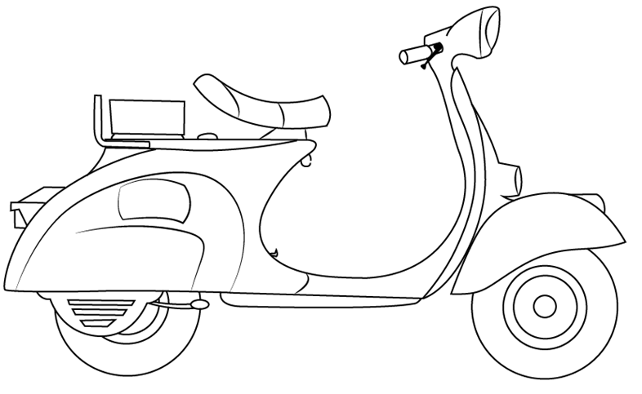

_____________________________________________________

____________________________________________________

____________________________________________________

______________________________________________________

___________________________________________________________________________________________________________________________________

RENTAL START DATE: _______________________ RENTAL END DATE: ____________________

PRICE: _______________________ DEPOSIT TAKEN : €_____________________

REFUND: €____________________________

IBAN/ACCOUNT NO: ____________________________________

BIC/Sort Code: ________________________________________

ACCOUNT NAME: ______________________________________

Terms & Conditions
- Riders must be 21 years and over. Under Spanish Law, any person with 3 years of experience with an ordinary driving license (B) is authorized to drive motorcycles up to 125cc.
- Riders must have some experience driving a 125 cc scooter or a motorbike. We are unable to rent to complete novices.
- DAMAGE TO THE VEHICLE. The renter (tours and rentals) agrees to cover any type of damage that occurs in the vehicle during the rental period both in circulation and in parking. The lessor may retain the part of the deposit that he deems appropriate to cover the repair in the the case of rentals. In the event of a tour, a credit card details will be taken. Once concluded this, will present the corresponding invoice to the lessee, liquidating the part of the remaining deposit, if any. In the event that the repair is higher than the deposit, in which case the renter will be solely responsible, and the lessor may exercise the judicial, civil or criminal actions that he deems appropriate.
- The scooter is insured for third parties damages, voluntary third party liability, legal defence. Conductor accidents: Medical cover. 12.000euros for death. 12.000euros for Invalidity and travel assistance i.e. breakdown cover.
- The renter is responsible for any collision, accident damage or theft of the scooter for the costs of the vehicle up to a value of EUR 2000.
- LOSS OR THEFT OF THE VEHICLE Theft insurance is not induced, total or partial loss, damages (or any other prejudice) suffered in your own vehicle (or in your luggage, merchandise or personal objects transported in the vehicle), by any circumstance (either by vandalism or accident.
- As in the case of an accident, in the event of theft or total or partial loss of the vehicle, the lessee agrees to immediately notify the lessor of this fact, on the emergency telephone number and to provide. Full collaboration with the lessor, the competent authority and the insurance company in the investigation and defence of any investigation or process. If the vehicle is stolen or lost negligence of the lessee will be responsible and will pay the lessor the market value, according to the tables of the Ministry of Finance without this implying a resignation by the lessor to execute the civil and / or criminal legal actions that consider appropriate against the lessee, if the motorcycle is recovered. The lessee shall bear all the expenses that cause its revision and / or repair, as well as the lost profit incurred by the lessor according to the rates of the moment that the tenant knows. If the cause of the robbery was not due to the negligence of the tenant, he will only be responsible for the amount of the deposit deposited. In either case, the rental contract will be cancelled, without the lessee being entitled to any refund. In the event that the theft occurs on any of the accessories or parts of the vehicle, the lessee will be responsible for the theft and will indemnify the lessor for the official rate price of the manufacturer of the stolen part or accessory plus any other cost invoiced by the corresponding workshop.
- The renter understands there are risks related to driving a vehicle and that they are in good medical health and are physically fit to rent the vehicle. To this effect the renter affirms that they do not suffer from any illness or consume any medication not suitable for driving a vehicle that impair their ability to drive the vehicle safely. GRAN TOURISMO SPAIN has the right to refuse rental, if we deem the rider not to be safe for their own safety and that of GRAN TOURISMO SPAIN.
- Misuse of the vehicle any action that contravenes traffic regulations, the vehicle manufacturer's specifications, and the lessor's instructions. The abnormal wear, verified by the lessor, of the mechanical parts of the vehicle, especially tires, will be considered misuse of the vehicle and will be charged to the lessee
- ASSIGNMENT OF THE VEHICLE The renter may not assign the use of the vehicle to third parties except with the consent express and prior to the lessor that must be reflected when including them as additional drivers in the contract, In this case the renter will always be solely responsible, before the lessor and third parties, for the damages that are may cause in and with the vehicle, regardless of who was driving it at the time they were generated.
- LOSS OF KEYS, ANTI-THEFT AND HELMETS. The loss of the vehicle keys will be charged on the deposit deposited by the renter in the amount of the cost of replacing the key according to the manufacturer's invoice plus the management costs necessary to obtain it. In the same way the loss of the helmets will be charged on the deposit deposited by the renter in addition to a surcharge of FIFTY EUROS for expenses. In the event the deposit is not sufficient to cover the expenses, the renter authorizes the lessor to collect the corresponding amount from his card.
- DAMAGE TO OCCUPANTS AND THEIR ASSETS. The tenant and its occupant they know the insurance coverage that the lessor has contracted for the vehicle and exempt the lessor from all liability for any damage that may be suffered, both physical and material, derived from normal or abnormal use of the leased vehicle. They expressly know the risks of burns and / or cuts or any other that the use of a vehicle may produce. Likewise, the renter relieves the lessor of all responsibility for losses or damages that occur in objects left or transported in the vehicle by the renter or by any other person, or in their clothing, either during the term of the contract or after the return of the vehicle. The tenant must travel with the appropriate regulatory equipment and required by the competent authorities.
- FINES AND OTHER CHARGES, The renter agrees to pay all fines for any violation of current and applicable Spanish legislation, especially the relative to the circulation and transport regulations that are imposed on it, as well as the expenses derived from the withdrawal of the vehicle from the public highway by the political authorities, in case of fines that require the identification of the driver, the lessor shall notify the competent authorities exclusively the identity of the renter.. The renter shall bear the legal and legal defence costs and costs incurred by the lessor arising from accidents or illegal conduct by the tenant and / or his companions. As well as the amount of the days that the lessor cannot freely dispose of the vehicle due to embargo, breakdown or damage caused to it during the lease attributable to the lessee.
- UNAUTHORIZED ACTIONS. The renter may not tow or push with the vehicle any type of vehicle or cargo, nor transport volume or weight greater than authorized in the Technical Inspection sheet of the Vehicle. Neither will you be able to participate in any type of sports or leisure tests. Racing or driving on unpaved roads. Teaching to third parties even in closed rooms, it is totally unauthorized. The vehicle may not be used or allow it to be used to carry out an illegal act including, among others, acts of smuggling or transportation of illegal substances. The tenant may also not pawn or sell the vehicle in its entirety or by parts, equipment, accessories and documentation, in any way that violates the property rights of the lessor or any other right that the owner has over the vehicle, Failure to comply with these prohibitions will automatically lead to the cancellation of the contract, and the renter will be responsible to the lessor for all fines, confiscations, liens, recovery, costs storage and judicial and legal representation. It is expressly prohibit
- VEHICLE RESERVATION, The lessor will inform the lessee of the availability on the dates of consultation, If due to force majeure, the lessor could not have the selected motorcycle, it will provide the lessor with another model, with characteristics similar or return the reservation
- CANCELLATIONS
Rentals - 48 hours or more - Full Refund Less than 48 hours 50% refund.
Guided Tours - 30 days or more - FULL REFUND 15 - 30 days - 50% refund. Less than 15 days - No Refund
- RENTAL PRICE includes rental + a deposit of €200. In no case may the deposit serve for an extension of the rent. Payment of these amounts must be made by credit, debit or cash card. The renter authorizes the lessor to charge all debits to his credit or debit card amounts accrued by this contract, both in the concepts of bail, rent, damages produced and total or partial theft.
- GUIDED TOURS: Payment in full must be made 30 days before commencement of the tour at the agreed quoted price.
- The renter agrees to rent the vehicle selected and declares whatever their nationality and language have read and understood this contract. Agreeing to resolve any doubt or disagreement that may arise from the interpretation and compliance itself, both parties expressly waive their own jurisdiction and submit to the Courts of Almeria. This contract may be delivered to the renter translated in another language. In case of dispute, the contract that takes precedence is the contract original written in English.
- The renter acknowledges that he receives the vehicle as described on Page. 1 on the contract, in perfect working condition with his documents and accessories (helmet, keys etc..) and undertakes to keep them and driving the Vehicle under the rules of the Traffic Code and in accordance with the specifications of use of the type of Vehicle.
- Gran Tourismo Spain will acknowledge and declare any prior damage before the rental commences. These will be marked on the contract and may not be claimed by the Leaser.
- The renter must refuel the vehicle with the appropriate fuel (unleaded) suitable for it and return with the same amount as at the commencement of the Contract. The renter will be responsible for the costs caused by the transfer and/or repair of the damage that may occur of the vehicle for the use of inaccurate fuel.
- The vehicle will be returned to the same address as per the contract at the agreed time and date. Any delay in return which is not caused by force as provided in Article 1105 of the Civil Code will result in a penalty of €40 per hour or part hour. Early return of the vehicle must be agreed with GRAN TOURISMO SPAIN prior to the return.
- In the case of misuse of the vehicle, the Lessor will demand early return and the renter will return as soon as this is issued, waiving any claim for rental rights. Non-compliance will result in The Police will be denounced and the vehicle considered as stolen.
- If for mechanical reasons the vehicle cannot be leased, the reasons being beyond the fault of GRAN TOURISMO SPAIN, and another vehicle cannot be provided, any remaining monies from the date of the fault will be returned.
- In the event of breakdown or accident, the renter must contact GRAN TOURISMO SPAIN and then the Breakdown Recovery Service as detailed in the insurance documents to arrange recovery.
- Only the person that is listed in the scooter rental agreement, and who is in the possession of the required driving licence, is eligible to drive the scooter.
- Scooters cannot be used off-road. In case the scooters have been used off-road all damages (including motor damages) are burdened by the renter.

I have read and understand the terms and conditions on this page and the front of this rental agreement and I authorize with my signature for all amounts derived from this rental to be charged to my credit / debit or deposit card account.

VERY IMPORTANT: IN ACCIDENTS DUE TO INFLUENCE OF ALCOHOL OR DRUGS, THE COVER OF THE INSURANCE POLICY WILL BE AUTOMATICALLY CANCELLED

Signed: ___________________________________ Date: __________________________

